A Critical Review of “Congestion Avoidance and Control” by Jacobson and Karels
Van Jacobson and Michael Karels’s 1988 paper, “Congestion Avoidance and Control” is a simple yet remarkable work in network engineering that is born from the urgent need to address the internet’s first congestion collapses occurred in October of 1986. The paper was presented at SIGCOMM (1988) that diagnosed the root causes of instability in transport protocols and introduced a set of working algorithms that would become the solid foundation of modern TCP. Even though practical choice of some parameters/constants (i.e. ai, md) invites further possible improvements, the paper’s whole success lies in its application of robust theory to create simple, implementable and highly effective solutions.  The paper’s central thesis is that network stability can be achieved by enforcing a packet conservation principle where a new packet is injected into the network only after an old one has been acknowledged. Slow-start algorithm to gently pace up new connections, round-trip-time (RTT) variance estimation to calculate accurate retransmit timeouts, and the additive increase/multiplicative decrease (AIMD) approach for congestion avoidance, are the proposed solutions that effectively improves and make the principle robust. Practicality alongside the theoretical vision and demonstration through data, is the core strength of this paper. The difference between the Figure 3 | (without slow-start) and Figure 4 (with slow-start) relays immediate visual and practical proof of how the implementation actually work. Nevertheless, test demonstration of multiple simultaneous TCP connections before (Figure 8) and after (Figure 9) congestion avoidance are very effective. While Figure 8 indicates that almost half the data packets were retransmitted, Figure 9 shows that only 1% of the packets were retransmitted. The fact that these solutions were wrapped in just a few lines of code, is a great indication of simple-yet-elegant design.  Logical Implementation  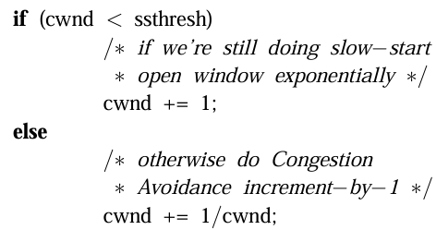  As we know that no system or solutions are perfect, same applies to the paper where the authors are very frank and informed about its limitations of their practical/heuristic choice. The choice of the additive increase (AI) with value 1 packet is admitted by the authors to be potentially aggressive. Also, the whole solutions are primarily for state-oriented window based protocols like TCP, not connectionless protocols (UDP, …). While the authors acknowledge that the end-to-end congestion control alone cannot ensure fairness, the general approach/solution for the problems are well illustrated with the help of figures and pseudo codes.  In summary, the paper is somewhat a marvel of system research consisting of | minimalistic yet profound approaches and solutions. It transformed TCP from a problematic congested protocol to reliable and effective protocol that covers and aids in avoiding congestion in a network. Even though parameters like AI and MD value (1 and 0.5 respectively) can be finely tuned to fully utilize the network bandwidth with fairly good start, the paper in general, remains a masterpiece of network systems design demonstrating how deep insight into a problem can bring out simple yet robust world changing solutions.

